# Build up your own Multichain network

## Preparation

Log on to your SAP Cloud Foundry Account (e.g. a Trial Account) and navigate to your space (e.g. dev space). Create one Multichain instance if you do not have one (refer to Hands-On “Create your first Multichain Node”). This instance will contain the node to be connected to.  
Navigate to its Dashboard:

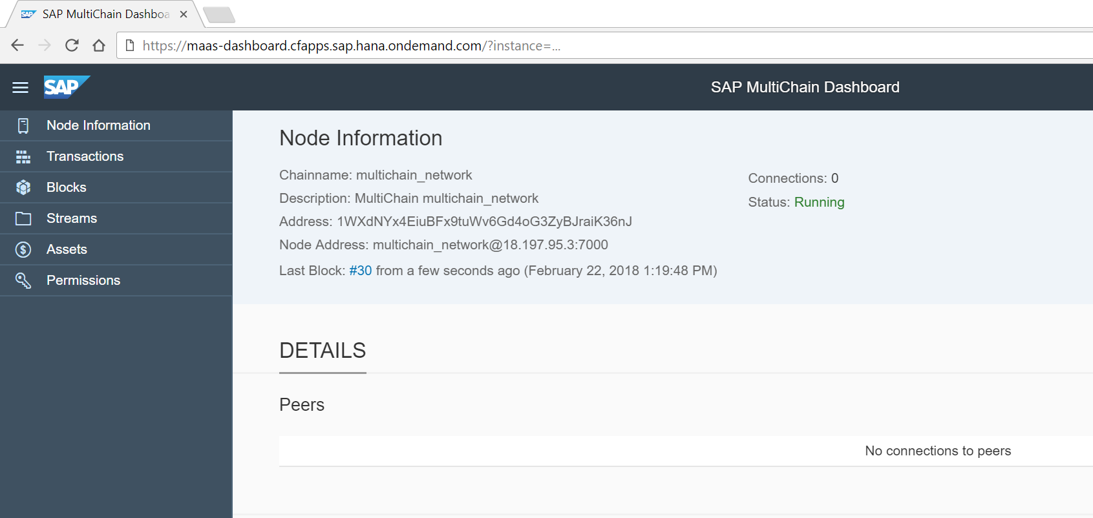

## Execution

In node address you find the node address that will act as connect url: <chainname>@<ip address of node>:<p2p port>. Note it down. The prefix is the chainname of the Multichain chain (e.g. mc8532081947941283521 or your name o choice) , the IP address of the node and its P2P port (which is 7000 for all SAP nodes).

You will now create a new Multichain node that will be connected to the first one. In this tutorial, we will create the new instance on SAP Cloud Foundry, but it will also work from any other cloud provider or even on-premise, if the relevant ports are open there.

For this, go back to your Multichain service in Cloud Foundry and create a new instance. In step “Specify Parameters” enter the a json with your connect_url to let your new instance connect to the first node. Taking the above screenshot, it is the following json (change chainname and ip address to your parameters):

{

"connect_url": "multichain_network@18.197.95.3:7000"

}

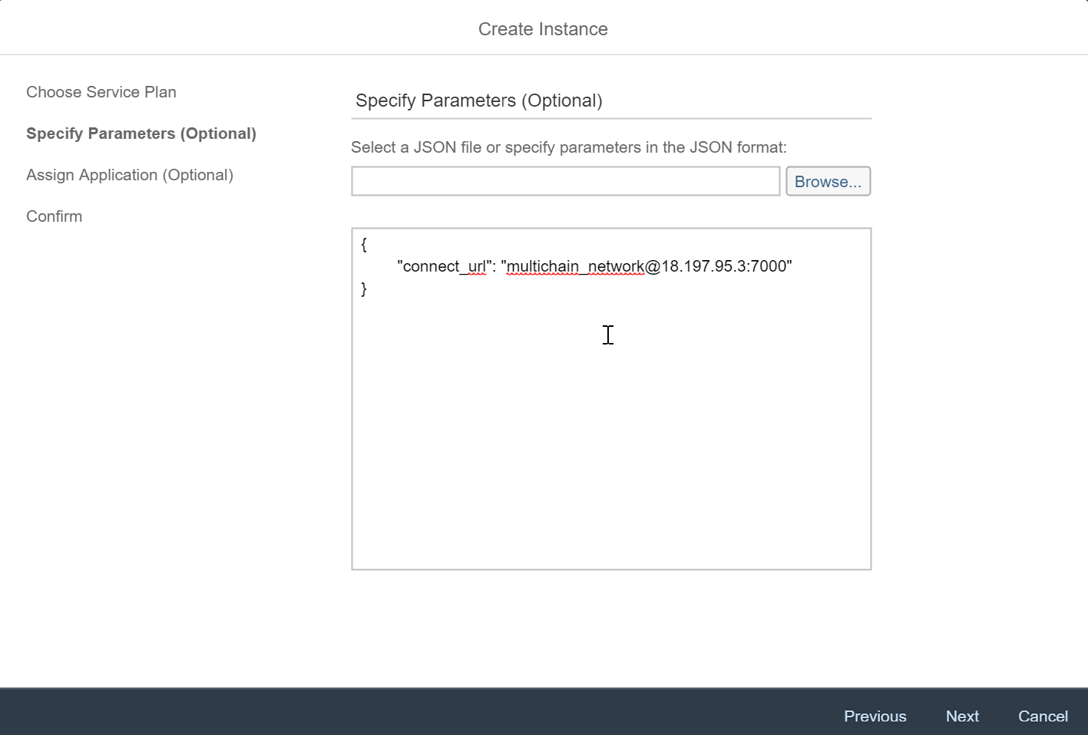

Finish the setup configuration. Your new instance is will be created.

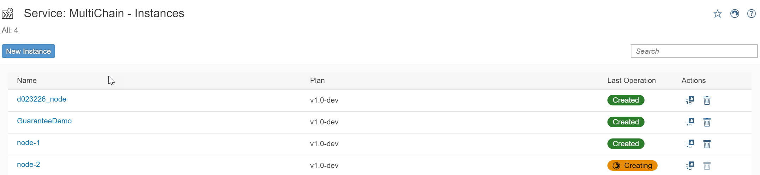

Once the new instance is created, you may create a new service key for it and get a new api key and the rpc URL for this second node.

When you enter the dashboard of the newly created node you will see that your node is awaiting network admission.

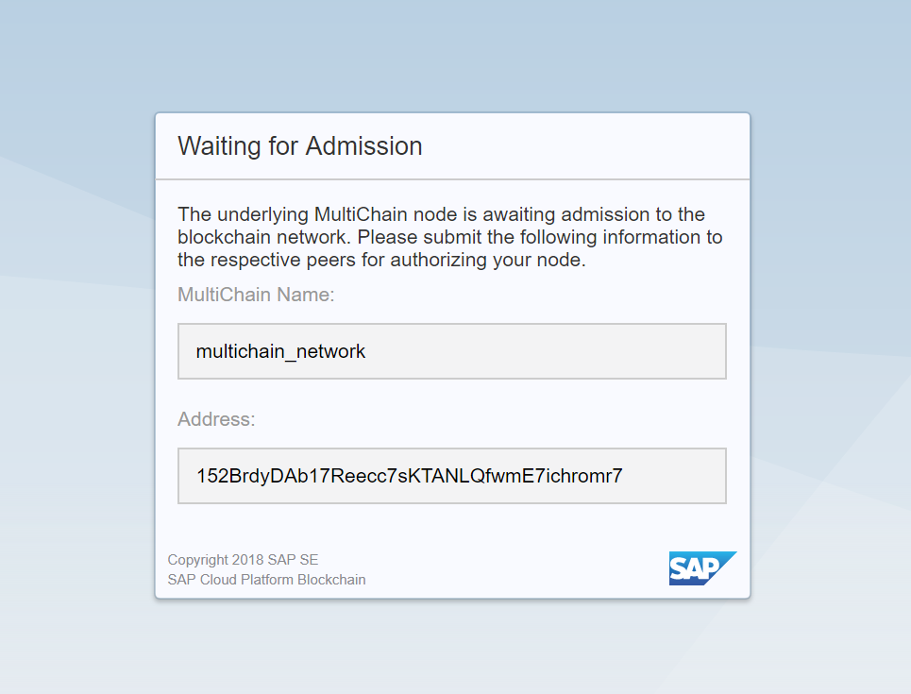

Your second node waits for granted permissions from the first node. Note down the address to be granted.

You now may grant permissions using json-rpc command grant or use the Multichain Dashboard of the node to be connected to. We show how to do this using the Multichain Dashboard. Switch to the Dashboard of the first node and click on Permissions in the navigation bar.

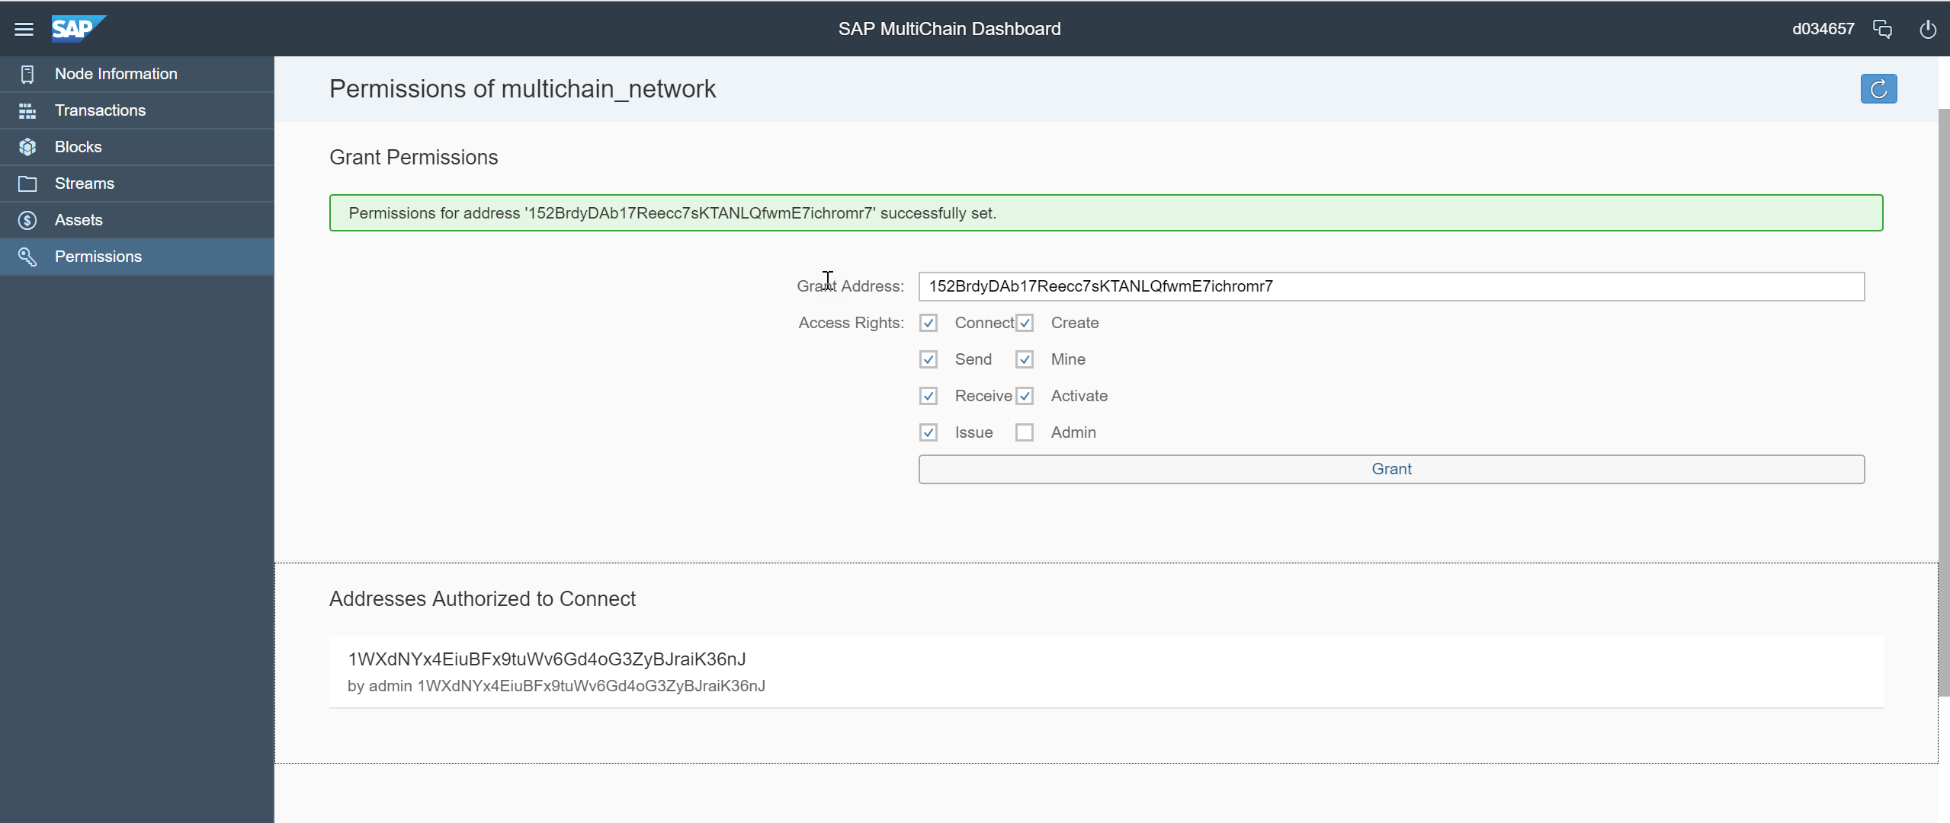

Enter the address you have just noted down and select the permissions you want to be granted (for details on permissions have a look to <https://www.multichain.com/developers/permissions-management/> ). Click on grant. Technically the json-rpc command grant is sent to the first node.

Once your node (or more precisely your address) was granted and it will be shared to all nodes connected to and you will see the connection details in the dashboard (click on browser refresh) of the second node:

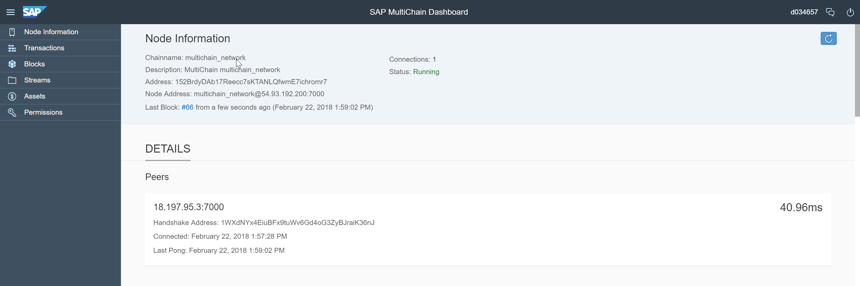

On the right upper corner you see the peers connected. On the peers tab you can monitor the current peer information.

You have successfully build up your blockchain network with two multichain instances.